**University of Engineering and Management**

**Database Management System Laboratory**

**MCAC 291**

**ASSIGNMENT 2**

1. **Consider the following schema for a Library Database:**
2. **BOOK (Book_id, Title, Publisher_Name, Pub_Year)**

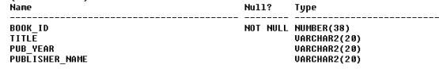

1. Make BOOK_ID as Primary Key
2. Make PUBLISHER_NAME as foreign key of NAME field PUBLISHER TABLE
3. **BOOK_AUTHORS (Book_id, Author_Name)**

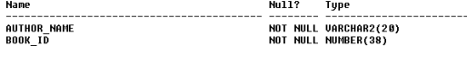

1. **Make Author_NAME and BOOK_ID as Composite Key**
2. **Make Book_ID Foreign Key of BOOK_ID field of BOOK table**
3. **PUBLISHER (Name, Address, Phone)**

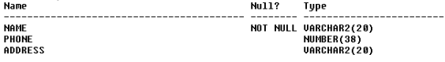

1. **Make Name as Primary Key**
2. **BOOK_COPIES (Book_id, Branch_id, No-of_Copies)**

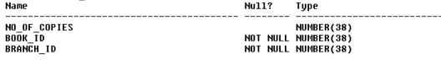

1. Make BOOK_ID, BRANCH_ID as composite Key
2. **Make Book_ID Foreign Key of BOOK_ID field of BOOK table**
3. **Make BRANCH _ID Foreign Key of BRANCH _ID field of LIBRARY_BRANCH table**
4. **BOOK_LENDING (Book_id, Branch_id, Card_No, Date_Out, Due_Date)**

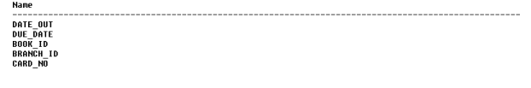1. **The data type for DATE_OUT and DUE_DATE DATE will be date**

1. **Make Book_ID Foreign Key of BOOK_ID field of BOOK table**
2. **Make BRANCH _ID Foreign Key of BRANCH _ID field of LIBRARY_BRANCH table**
3. **Make CARD_NO Foreign Key of CARD_NO field of CARD table**
4. **Make BOOK_ID, BRANCH_ID, CARD_NO as composite key**
5. **LIBRARY_BRANCH (Branch_id, Branch_Name, Address)**

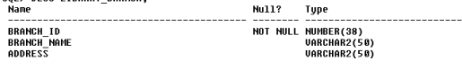

1. **Make BRANCH_ID as Primary Key.**
2. **Card (CARD_ID)**



1. **Make CARD_NO as Primary Key**

**Data for the PUBLISHER tables**

1. **‘MCGRAW-HILL‘, 9989076587, ‘BANGALORE‘**
2. **‘PEARSON‘, 9889076565, ‘NEWDELHI‘**
3. **‘RANDOM HOUSE‘, 7455679345, ‘HYDRABAD‘**
4. **HACHETTE LIVRE‘, 8970862340, ‘CHENAI**
5. **GRUPOPLANETA‘,7756120238,’BANGALORE‘**

**Data for the BOOK tables**

1. **1,‘DBMS‘,‘JAN-2017‘, ‘MCGRAW-HILL’**
2. **2,‘ADBMS‘,‘JUN-2016‘,’MCGRAW-HILL‘**
3. **3,‘CN‘,‘SEP-2016‘, ‘PEARSON’**
4. **4,‘CG‘,‘SEP-2015‘, ‘GRUPO PLANETA’**
5. **5,‘OS‘,‘MAY-2016‘, ‘PEARSON‘**

**Data for the BOOK_AUTHORS tables**

1. **‘NAVATHE‘, 1**
2. **‘NAVATHE‘, 2**
3. **‘TANENBAUM‘, 3**
4. **‘EDWARD ANGEL‘, 4**
5. **‘GALVIN‘, 5**

**Data for LIBRARY_BRANCH tables**

1. **10,‘RR NAGAR‘,‘BANGALORE‘**
2. **11,‘RNSIT‘,‘BANGALORE’**
3. **12,‘RAJAJI NAGAR‘, ‘BANGALORE’**
4. **13,‘NITTE‘,‘MANGALORE**
5. **14,‘MANIPAL‘,‘UDUPI‘**

**Data for BOOK_COPIES tables**

1. **10, 1, 1**
2. **5, 1,11**
3. **2, 2,12**
4. **5, 2,13**
5. **7, 3,14**
6. **1, 5,10**
7. **3, 4,11**

**Data for BOOK_COPIES tables**

1. **100**
2. **101**
3. **102**
4. **103**
5. **104**

**Data for BOOK_LENDING tables**

1. **‘01-JAN-17‘,‘01-JUN-17‘, 1, 10, 101**
2. **‘11-JAN-17‘,‘11-MAR-17‘, 3, 14, 101**
3. **‘21-FEB-17‘,‘21-APR-17‘, 2, 13, 101**
4. **‘15-MAR-17‘,‘15-JUL-17‘, 4, 11, 101**
5. **12-APR-17‘,‘12-MAY-17‘, 1, 11, 104**

1. **Write a query to display the book id, card number from book_Lending table Where due date is 15-MAR-17 .**

**2. Rename table name card to card details.**

**3. Alter Column name satus to Book Lending Table.**

**4. Display all the books where number of copies id 5**

**5. Rename Column address of Branch_address in with varchar(50)**

**6. Write a query to display the Book id, number of copies who have not returned the books**

**7. Display all the addres of the branch Bengalore.**

**8. Write a query to display the publisher name of DBMS book.**

**9. Write a query to display the author name of DBMS book.**

**10. Write a query to display the book code, book title and author for all DBMS book.**